**Sprint 1 Plan**

**Goal**:

There are two goals in the Sprint Plan 1. The first goal is to familiarize ourselves with the technologies we are going to be using. All team members should use the first week to learn about the React Native and Firebase. The other goal is to implement the login page and related functions for our project.

**Task listing**:

* **As a developer, I want to be familiar with the frameworks I choose so that I know what I have to work with when writing new features.**
  + Estimated story points: 2
  + React Native, Firebase and expo setup and learning JS and html (**Everyone**)
    - Time estimate: 5 hours
* **As a user, I want to choose my account type automatically so that I can sign up as a patient or as a medical staff**
  + Estimated story points: 3
  + Build a data structure for user’s account in firebase (**Vineet**)
    - Time estimate: 1 hours
  + Implement username and password storage in firebase (**Vineet**)
    - Time estimate: 2 hours
  + Implement a login page UI (**Jeffrey**)
    - Time estimate: 2 hours
  + Implement a sign up page UI (**Howard**)
    - Time estimate: 2 hours
  + Use firebase to check account’s type
    - Time estimate: 1 hours
* **As a user, I want to have a forgot password button so that I can reset my password**
  + Estimated story points: 2
  + Implement forgetting password page UI (**Howard**)
    - Time estimate: 2 hours
  + Implement an email/password recovery system(**Adam**)
    - Time estimate: 1 hours
* **As an administration, I want to manage permission to the medical staff account so that I can give or remove permission of medical staff account.** 
  + Estimated story points: 3
  + Implement admin management page UI (**Howard**)
    - Time estimate: 2 hours
  + The actual code to edit the permission of accounts
    - Time estimate: 1 hours
* **As a user, I want to have access to the main menu so that I can see my options** 
  + Estimated story points: 3
  + Create two new pages but can be blank (**Howard**)
    - Time estimate: 1 hours
  + Navigate user to their main menu depending on their account type by login button (**Andrew Hartwell**)
    - Time estimate: 1 hours

**Team roles:**

Zhaoheng Chen (Jeffrey): Product Owner {Developer}

Howard Ng: Scrum Master {Developer}

Andrew Hartwell : Developer

Vineet Ramareddi: Developer

Adam Askari: Developer

**Initial task assignment:**

Each task is assigned to the following member in task list.

**Initial burnup chart:**

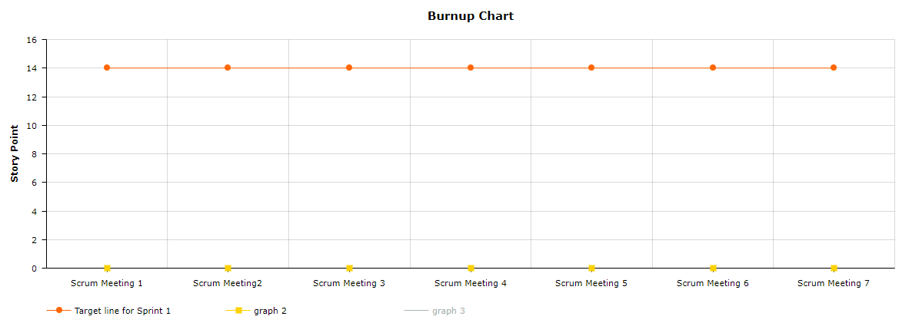

**Initial scrum board:**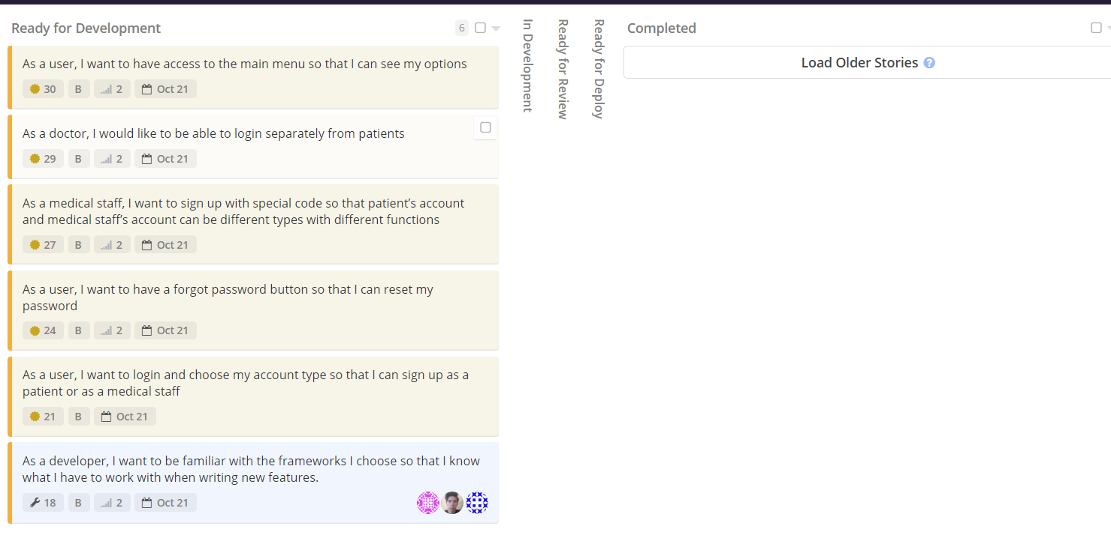

**Scrum times:**

MWF 2:40 BE302